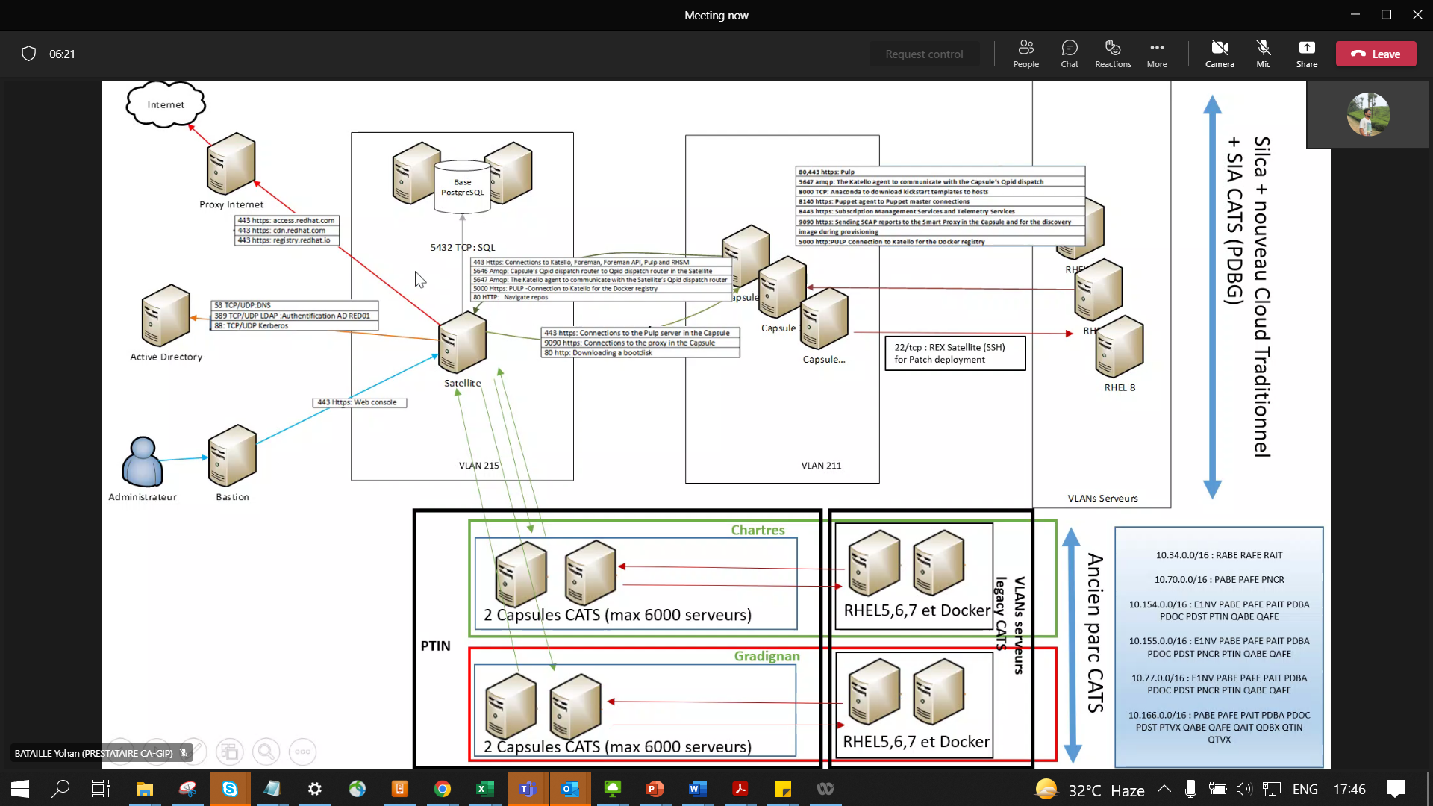

Satellite Master – only 1 master VM server.. Have access to Red01 AD

CPS = 3 for Ex-Silca + 4 for CATS (2 each in CHRTS – fxl01, 02, 2 in GRD – fxl03,04)

2 Postgre SQL – Databases – VM’s

Capsule VLAN – 211 is exposed (not 215 VLAN) are in ex-CATS SIA

(For new members we have to clone the user’s Red01 to the existing users for getting access).

Capsule acts like a Proxy

API requests will come to CPS Server

CPS group at below – is only for Legacy CATS

Latency = 50 times b/w CHRTS <🡪 GRD of that of DID 🡨> DAL

So Servers in GRD will connect to CPS in GRD CPS for better speed/Bandwidth

Total Servers ~ 21k

9000 = SoCLoud 3000 + Ex-Silca 6000 in above centre

6000 each in CHRTS & GRD

Postgre Repo:

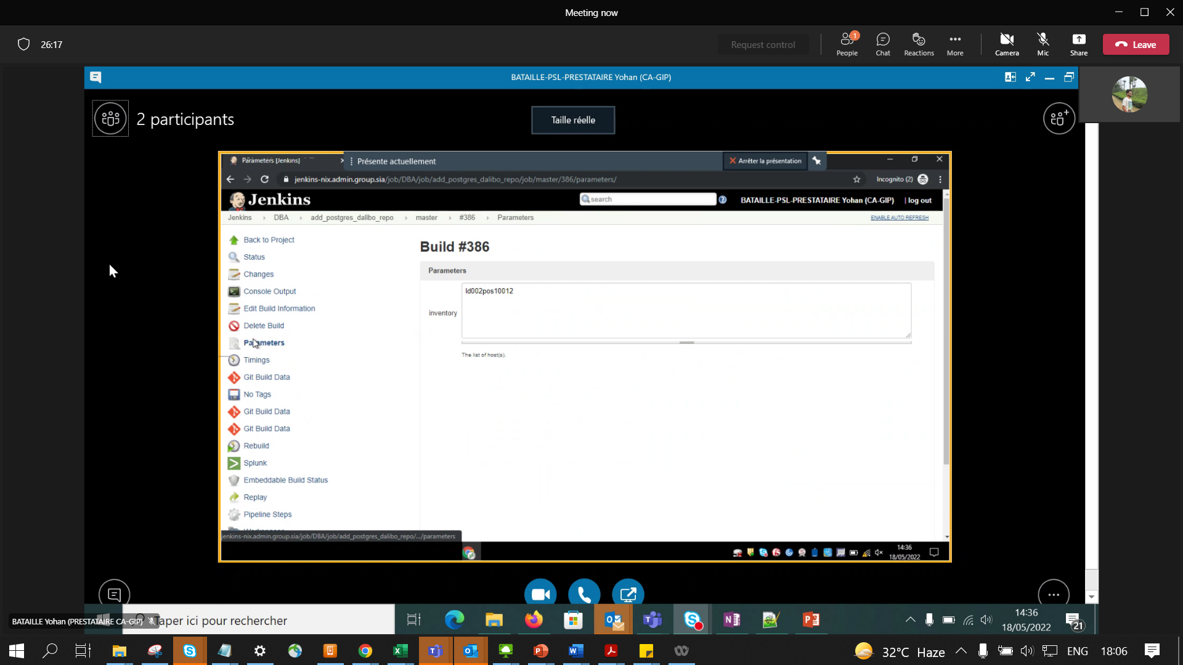

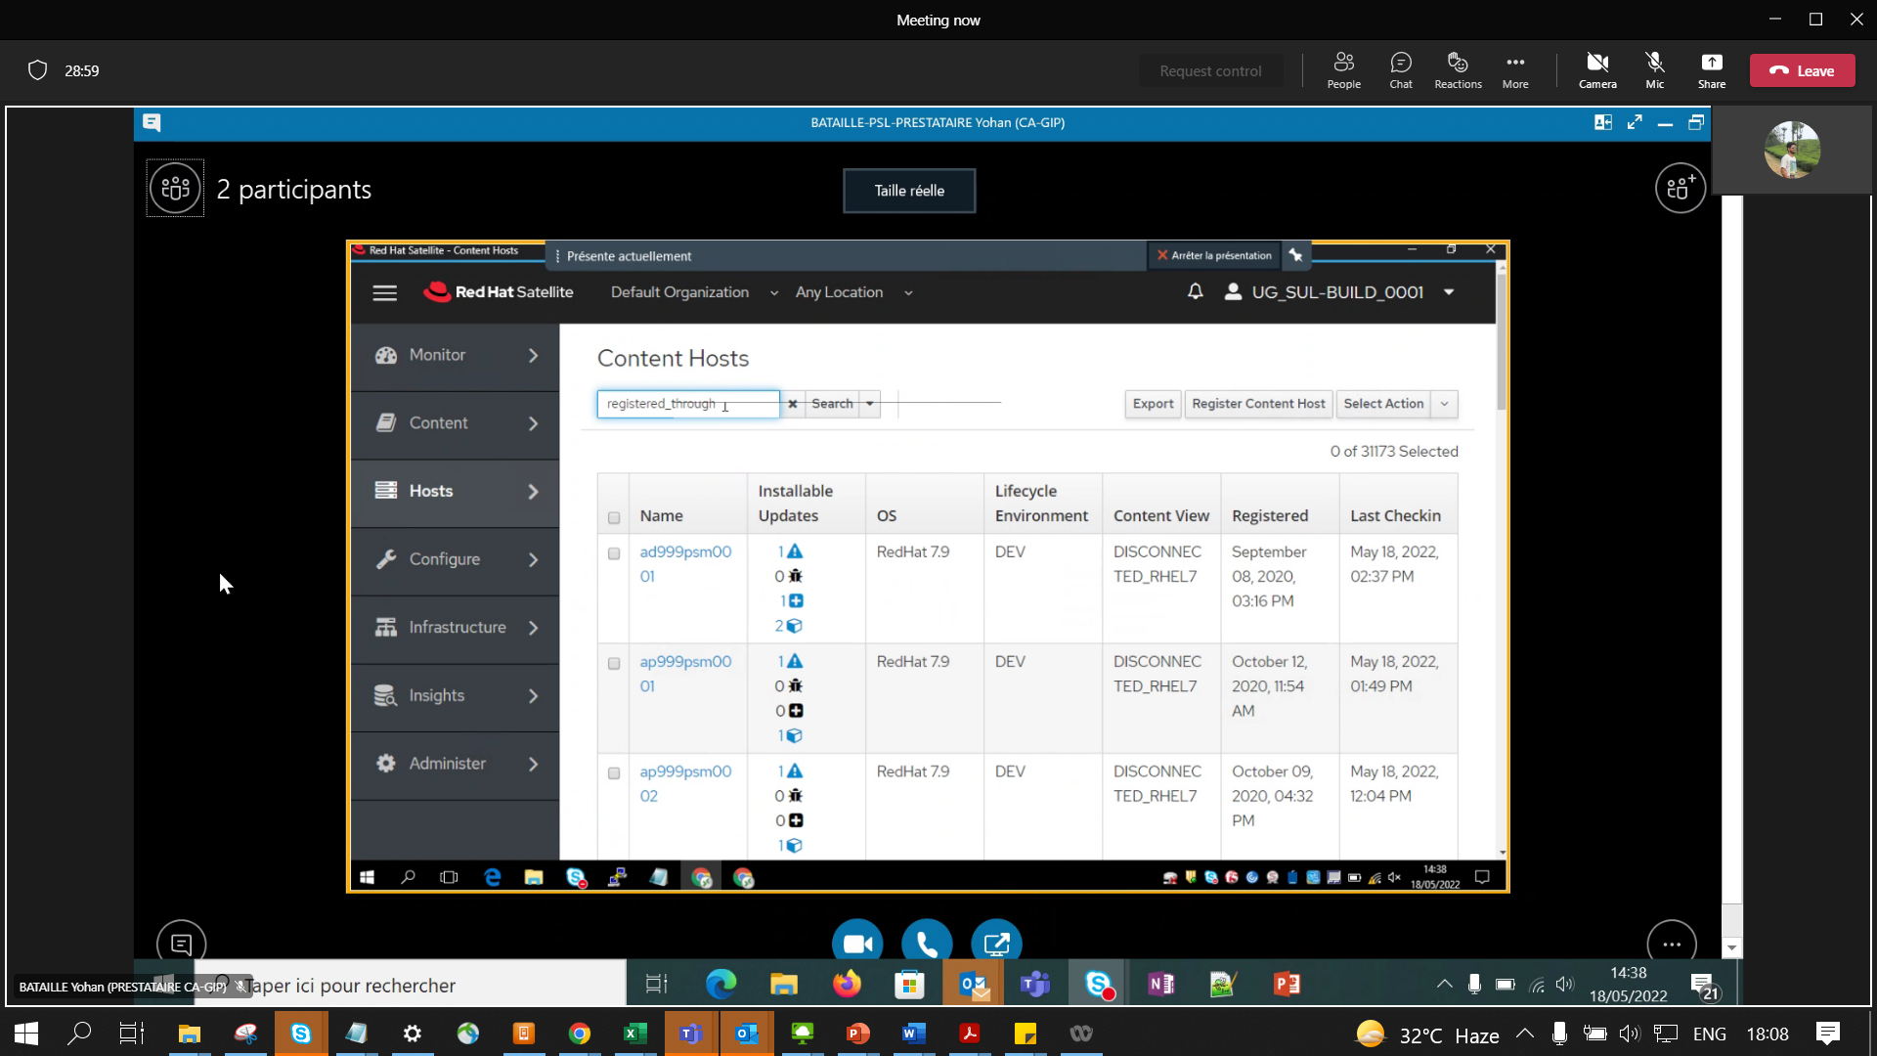

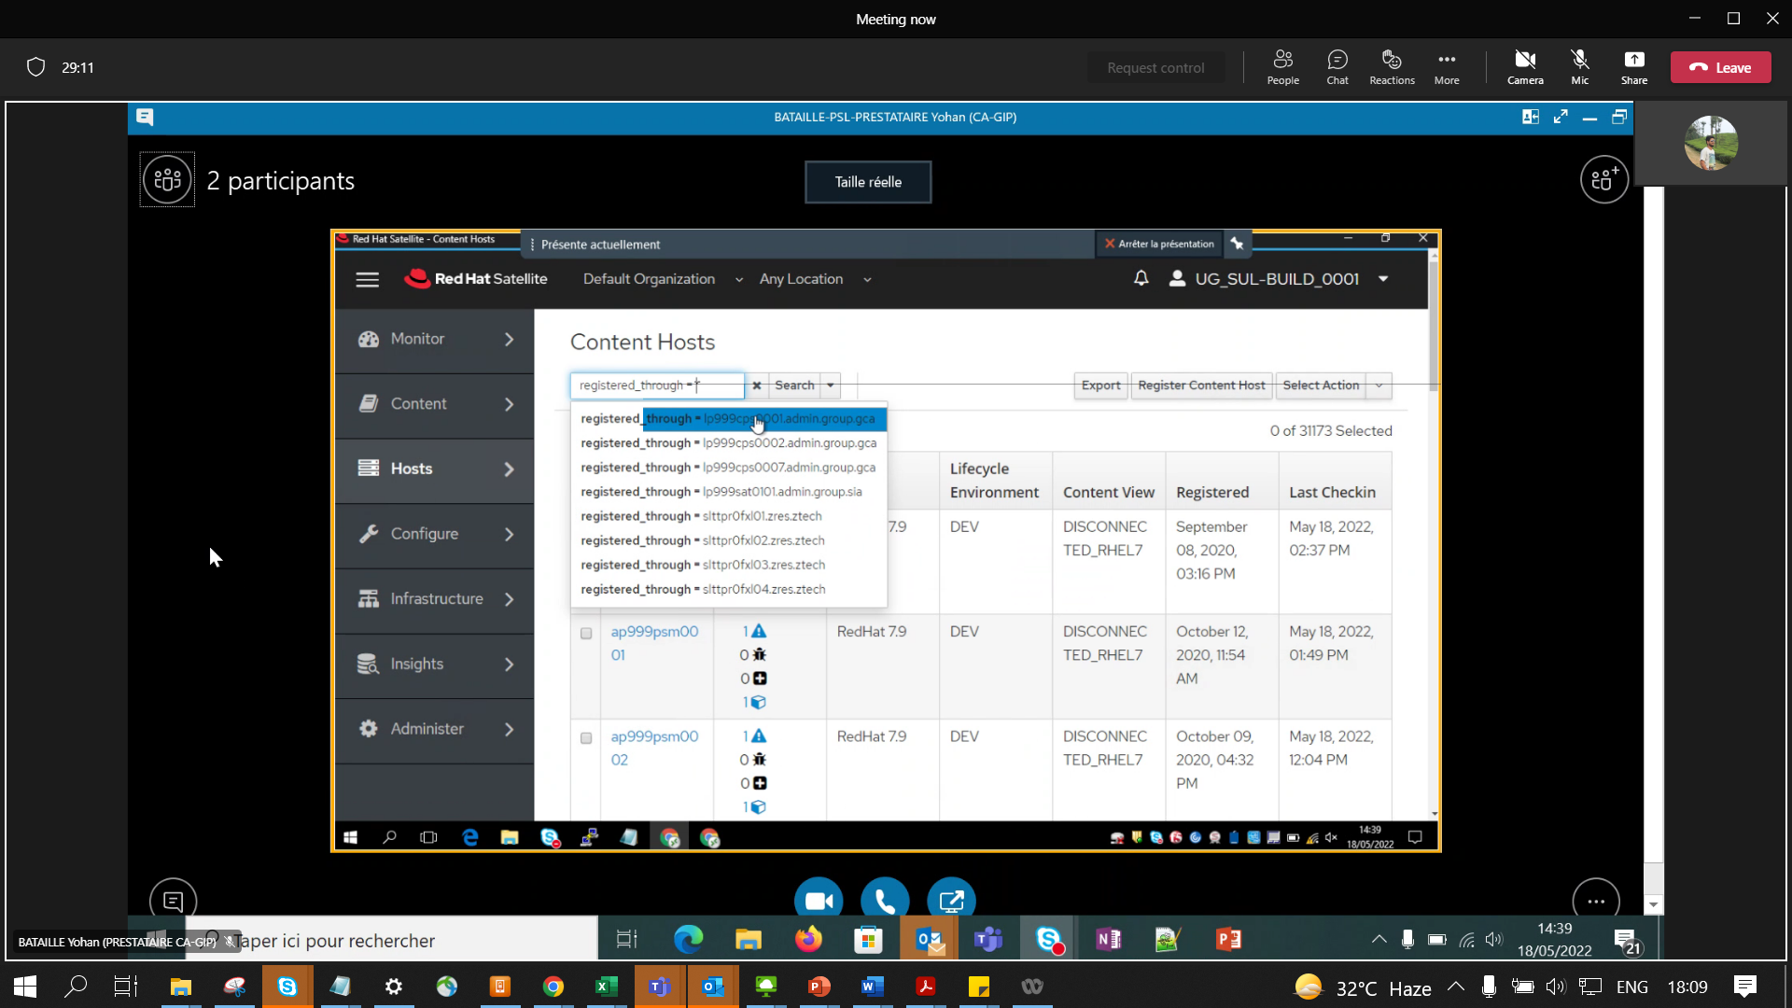

3500 servers per capsule (Redhat Recommendation <5000)

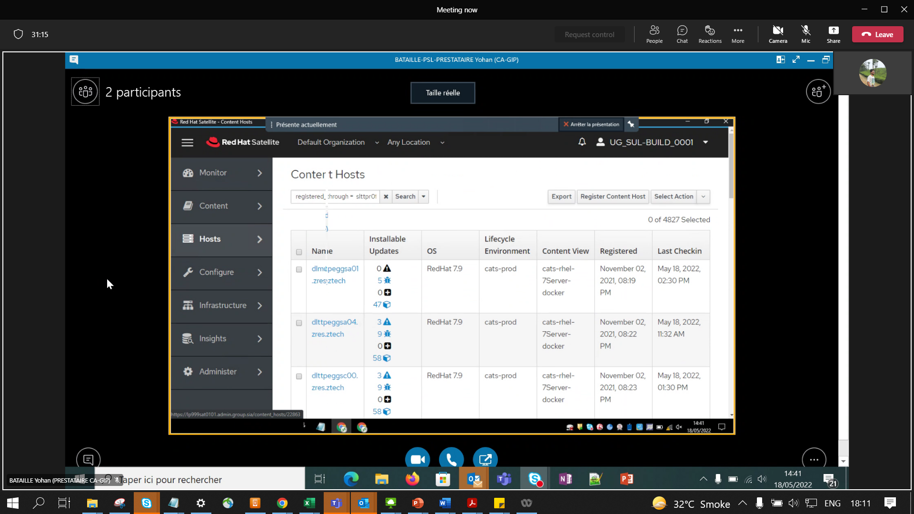

See count at rite top (6600+ in fxl01, 6400 fxl02, 4800 in fxl03, 4400 in fxl04)

Even Zres servers are also added to GRD CPS